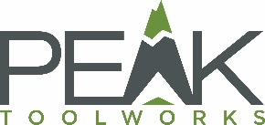
February 26, 2021
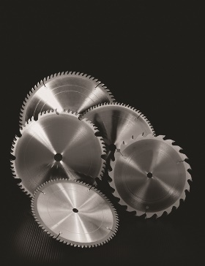
Saw Blades and other Woodworking Tooling: Customized or Standard?

It is a deceptively simple question. Do you need a custom woodworking tool or standardized one? Here are some factors to consider when you begin exploring the difference between these two options; and the answer is not always a clean cut.

There are positives to choosing a standard blade that can be ordered from suppliers. Using a standard blade is easier to find in inventory, it can comply with many applications and you know what you are getting. While this appears to simplify one of the considerations for your job, it may not always be the best solution or most cost-effective in the long run. Also, not all standard blades are general blades, some are designed for a specific purpose.

Custom tools fit the exact need you are trying to produce. This can provide better performance in throughput, cut rate, longevity, efficiency, less waste and quality of product. Very high production rates through small performance enhancements can positively influence your bottom line. When a carbide tip tool is replaced with a diamond tip, the performance enhancements listed are even more noticeable. Including, less wear that decreases downtime for sharpening. It is common for tipped tools to last decades if they have scheduled maintenance.

A strategic partner can help you design the custom tool(s) you need to realize your leanest operation. Customized tools can be designed to address specific defects that are creating an issue in your production. Understanding your needs in creating the tool also makes them a great choice when your tooling requires sharpening because it streamlines your supplier relationship. Additionally, when a tool is made by a local supplier, it decreases inventory delivery time.

A lot of times a standard blade makes sense, but if you are trying to enhance and dial in your performance a customized tool might be the better option. If your standardized tooling is not giving you the desired performance, consider a customized tool. The choice of customized or standard tooling is always yours, which one will help you reach your peak performance?

Peak Toolworks is celebrating 80 years in the carbide and diamond tooling industry. They have a vast portfolio that includes: Peak, NAP, Gladu, General Saw, RKO, Riverside Tool and tool sharpening. Follow us on social media or contact us today: sales@peaktoolworks.com 1.800.457.7468 French customers: demandes@peaktoolworks.com 1.800.363.9117

